**Polarization from a Complex Systems Perspective**

Recall what Richard Nixon said about the differences between Democrats and Republicans in the first televised presidential debate in 1960: “We differ on means, not on ends.“ Later in that debate Nixon asserted that Kennedy’s motives, like his own, “are sincere.” Such statements are inconceivable in today’s hyperpolarized climate. Nixon and Kennedy had a polite conversation. The first presidential debate between Donald Trump and Joe Biden had the candidates, especially Trump, shouting over one another, with Biden eventually telling Trump to shut up. The loss of civility in political discourse is perhaps the most striking feature of contemporary American politics. But loss of civility is but one sign of hyper- polarization in terms of ideology and race and region.

The deep divisions with respect to race lead to what one of us has called an *ethnicized party system*, with whites on one side and minorities on the other. Ideological lines have hardened, with partisans holding correlated issue positions across seemingly independent issues such as environmental protection, immigration, taxation, and gay marriage. Voters who identify with the Republican party also have very different beliefs about factual matters such as the extent of racial discrimination or the evidence for global warming, or fraud in the 2020 election, than voters who identify as Democrats. And geographic sorting, means that **80**% of the states have been safe for one party for decades **JONATHAN THINK ABOUT accuracy of percentage**;while patterns of immigrant location, and the continuing economic decline of rural areas have meant that Democratic cities face a Republican countryside, with the areas “in play” mostly suburban ones..These divisions re accompanied by a rise of negative partisanship, with parents increasingly unwilling to see their children marry across party lines.

Here we draw on recent scholarship by ourselves and others to evaluate factors that shape hyper-polarization and to consider potential remedies.

First, we would emphasize is that understanding the *causes* of polarization requires us to go beyond formal institutions to take a complex systems point of view in which we acknowledge that formal institutions are embedded in the wider society.

While it is natural to look to institutional reform as ways to remediate polarization, and we discuss possible reforms in this essay, we cannot explain the differences between 1960 and now by changes in the formal institutions of governance. A variable cannot be explained with a constant. U.S. institutions are, in most respects, fixe, yet indices of polarization show that it was far lower in 1960 than it is today.

There are many features of society and economy that mediate/structure polarization.

One such is demographic change due to immigration, especially after the passage of a new immigration law in 1965, and the change in the racial composition of the southern electorate after the passage of the Voting Rights Acts of 1965 (Alt, 1990). The change in the degree to which politics at various levels is competitive and to which competition varies by region and by type of economy is linked to these demographic changes, with race-conscious redistricting (Davidson and Grofman, 1992) of particular importance in the South in shaping white perceptions of the Democratic party as the party of minorities.[1]

Another key factor is a change in the nature of jobs and the economy. These include a widening gap in income between the college-educated and the non-college-educated, a concentration of wealth in the hands of the super-wealthy corresponding with only very modest gains among those in the middle of the income distribution (Piketty and Saez 2003), and job loss that was geographically concentrated and largely disproportionately affecting the working class.

A third factor is change in the nature of political communication: with new types of media rising to prominence; the end of the ABC-CBS-NBC triad as voters’ accepted sources for reliable political news; and the siloization of political communication, with voters increasingly getting news from sources that provide an echo chamber for ideological views of a particular type and reinforcement of absurd conspiracy theories and rumors blasted with warp speed across social media networks.

.

Second, we would emphasize that polarization trends long predate Donald Trump and are not just about what has happened on the Republican side of the partisan divide, and that accordingly, return to a more civilized universe should not be expected to happen overnight .

There was a steady but very slow upward trend in polarization beginning in the early 1950s for Democrats and the late 1970s for Republicans. It took us along while to get where we are now, and the process was incremental.

While we share the view, most recently and cogently expressed by Robert Putnam in *The Upswing,* that today’s hyper-polarized politics closely resembles that at the end of the 19th century, we would emphasize the likely time frame for any reversal. Examination of Poole and Rosenthal data on partisan polarization in congressional voting suggests that reducing polarization from its late 19th early 20th century highs was an incremental process taking over 60 years, and our present polarization is the result of an incrementally upward pattern that has already lasted more than 50 years (see Figures 1 and 2, which plot the first dimension of DW-NOMINATE scores for the House and Senate). Thus, while we acknowledge a key point in Putnam that, if 19th century polarization could be reversed, then the same should be possible today, even if polarization trends begin to reverse, it may well take another fifty years or more **before we return to a politics of civility. JONATHAN THINK ABOUT WORDING**

.

**I CAN RECREATE THIS TO MATCH WHATEVER STYLE WE WANT. WE JUST NEED LINES, MAYBE 95 CONFIDENCE LIMITS NOT ALL THE DOTS PROBABLY WE WILL DROP BOTH THESE CHARTS AND SIMPLY CITE TO POOLE AND MCCARTY OR PERHAPS, TO ANOTHER ARTICLE IN THIS SYMPOSIUM THAT ALSO HAS THESE FIGURES.**

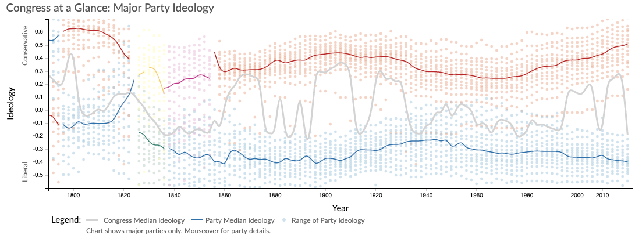

**Figure 1**

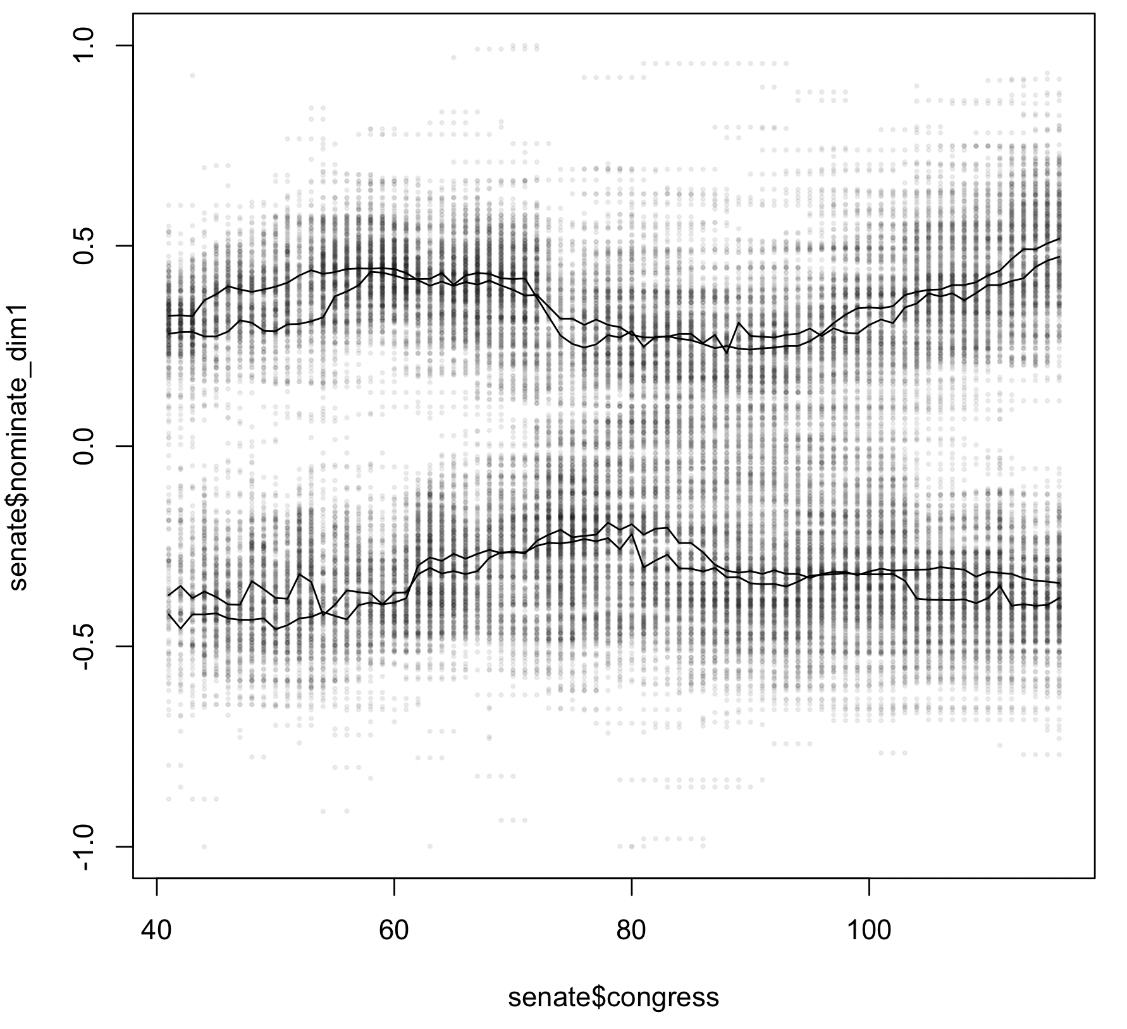

**Figure 2**

Looking at geographic aspects of polarization, we find that the patterns of which states are safely Democratic and which safely Republican in 2020 is essentially the mirror image of that in 1900. To make that point more apparent, Figure 3a uses black for the states with above the median Democratic two party vote share in 1900, but in Figure 3b use black for the states with above the median Republican two party vote share in 2020 . This mirror image pattern reflects what we label *angular realignment****, i.e.,*** incremental change in political strategies to make inroads into the other party’s supporters, as described/modeled in Miller and Schofield (2008).[2] They seek to explain the type of long term ideological shift in party platforms that, over the course of a century, took the Republican Party from being the party of Lincoln to the party exploiting white racial backlash, and from being the party of the North to being the party of the South

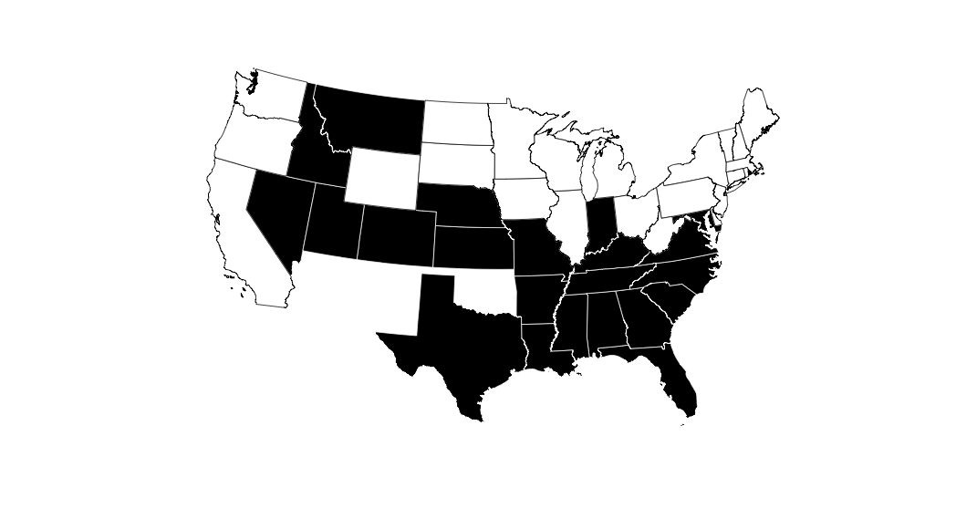

Figure 3a States with Democratic Vote Share above the Democratic Median Vote Share in the 1900 Election

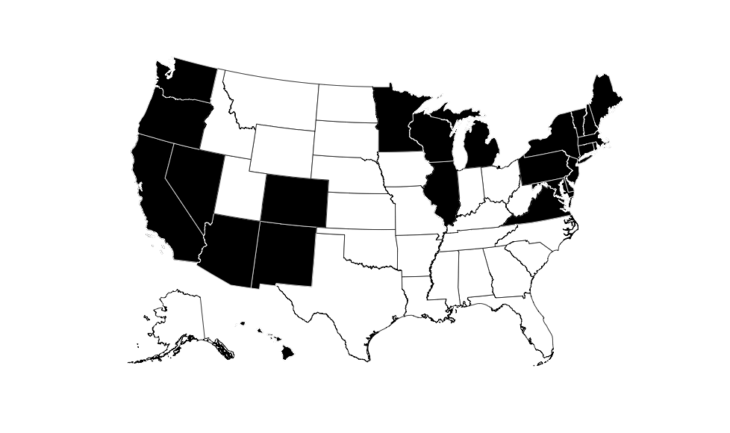

Figure 3b States with Republican Vote Share above the Republican Median Vote Share in the 2020 Election **JONATHAN YOU WILL NEED TO REVERSE THE COLORS ON THIS MAP**

Third, the causal effect of structural features on polarization cannot be modeled in a linear way; there are complex interactions and reciprocal causalities.

**An example of reciprocal causality is how some formal but internal aspects of institutions are both consequences of polarization and act to reinforce it. For example, the desire to end the Senate filibuster for judicial appointments was triggered by polarization, but the consequences of allowing one party to control judicial appointments without input from the other party operate to raise still further the stakes of partisan control of congress and the presidency. The confirmation votes for justices are now entirely along partisan lines. [3]**

Another feedback loop is about how the extent to which candidates at the district level are able to campaign on a platform ideologically distinct from the national party platform is linked to national level polarization. It is generally recognized that contests for the U.S. Congress has become increasingly nationalized, so that the destiny of a candidate for federal office is tied to national political forces (Abramowitz and Webster 2016; Carson et al 2019; Jacobson 2019). But much less well understood is that the tightness of the national party constraint on congressional candidates has varied over time in a way that can create a self-reinforcing pattern of increasing polarization (Merrill, Brunell, and Grofman 2014; Brunell, Grofman and Merrill, 2016). If candidates of a given party cannot stray far from the national party positions, then they cannot court the median voter in the district in the fashion that might be expected from Downsian logic (Downs 1957).The greater the national platform differences, proxied by the differences in party voting in Congress, *ceteris paribus*, the greater the expected gap between candidates of opposite parties at the district level; hence liberal districts will tend to elect liberal Democrats and conservative districts tend to elect conservative Republicans. Thus, over time, elected representatives from a given party come to look more ideologically homogeneous. But that fact enlarges the likely ideological gap between elected members of each party in any given district, and that makes it even more unlikely that districts with a liberal (conservative) median voter will elect a Republican (Democratic) candidate. And so the pattern repeats itself. Moreover, candidates are increasingly forced to sign on to the (previous) national position of their party as the ideological gap between the parties widens since, as that gap widens, the willingness of party leaders and activists to tolerate those who stray from the party line (i.e., centrists) declines (Thomsen, 2018) . When a member of Congress is replaced by a new member from the opposing party, the median voter tends to get “leap-frogged,” with the new member also relatively extreme but extreme in the opposite direction (Bafumi and Herron 2010).

Some feedback loops linked to polarization involve features of the current political landscape that we do not associate directly with polarization, such as highly competitive elections. **[4]**  Frances Lee (2016) offers what we regard as a compelling argument that, when elections are a knife‐edge for the presidency and competitive with respect to control of congress, then the stakes are seen as extremely high. This is particularly true when there is the possibility of trifecta control. Instead of compromise being the path to policy outcomes, obstructive politics for the minority party and bare-knuckled politics with no restraints becomes the weapon of the majority with focuson what can be done to hobble the opposition. As Lee (2016) has convincingly argued, with data including interviews with candidates and party leaders, when institutional control of all three levels of national power is up for grabs (because, for example, the U.S. House is no longer “constitutionally Democrat” as it was labeled in the post-WWII period when successful Republican candidates in the South were as scarce as hen’s teeth) then parties become more willing to pursue “scorched earth” politics.

**We must be careful, however, when we talk about levels of competition. The nation as a whole (Congress and the Presidency) can be highly competitive even though most states are quite uncompetitive. Figures 4 show time series for national competition in presidential elections (4a) and in the degree to which congressional delegations are evenly divided between the parties (4b). Our interest in the effects of closely competitive elections is reinforced when we observe that the high levels of competition we see today in both figures were also found at the end of the 19th century[5] –a period in which we also saw both high polarization levels and a high probability of a reversal such that the popular vote winner did not win the Electoral College. In contrast, no such reversals occurred during the 20th century.** Indeed, as we can see from Figure 4a, all four of the reversals in the modern political era occurred during one of these two 20 year intervals! While this should not be taken as particularly surprising once we take the closeness of elections in these periods as given, since it is well established that only when the popular vote is close is a reversal likely (see e.g., Miller, 2012), we would argue that EC reversals are a further exacerbation of polarization. They leave members of the party on the wrong side of the reversal bitter, and the party on the winning side of the reversal forced to come up with reasons to discount the popular vote as an indication of electoral legitimacy.[6]

**Figure 3.**

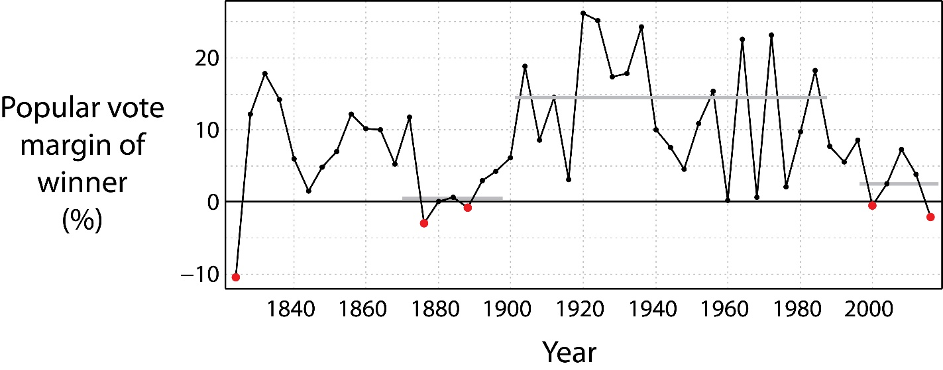**Presidential Winner Popular Vote Margin 1868-20xx**

**JONATHAN THIS NEEDS TO BE UPDATED TO 2020**

**Figure 4b. How Far from Evenly Divided were the U.S. House of Representatives and the U.S. Senate 1868-2000**

**JONATHAN TO PLEASE PROVIDE**

Extreme polarization generates obstructionism between branches when there is not trifecta control-- such as a Republican controlled Senate refusing to allow a vote on a Democratic nominee for the Supreme Court, and a bulldozer reversal of everything the other side has done when your side comes into power -- as witness Trump’s first acts in office being the reversing of President Obama’s executive orders. Polarization leading to incivility and norms violation by one side will ultimately be met with incivility and norms violation when the other side returns to power. And that, too, creates a feedback loop that is hard to break. Partisans on both sides have no claim on a mandate after a close election, but can point to significant support. The minority, who is locked out of the lawmaking process despite their significant electoral support, will look to undo what they can legitimately claim as an overstep by the previous legislature**.** Moreover, in general, high levels of polarization make it likely that political competition patterns tend to be frozen in place: the safe states districts largely stay safe and only the relatively few swing states swing with electoral tides, and the same pattern manifests itself for safe and swing districts.

Yet another feedback loop links polarization with party loyalty. As Merrill, Grofman and Brunell (2020) show, polarization make the parties more likely to rely on turning out their base rather than appealing to the center. Polarization increases party loyalties, and stronger party loyalties make it easier for more extreme candidates to mobilize their base to win, which in turn fosters greater contrast between the issue positions of the parties, which in turn, can strengthen party loyalties in a positive feedback loop. Relatedly, Merrill, Grofman and Brunell (2020) offer a formal model to show that polarization increases the strength of party attachment more at the extreme end of the ideological spectrum than it does for centrist votes. This motivates greater partisan involvement by party activists, whose greater impact on shaping party platforms reinforces polarization, again creating a positive feedback loop.

**Another feedback loop links polarization to gerrymandering.** The U.S. constitution requires districts in the House of Representatives **to be allocated on the basis of population,** and every ten years after the census, **states** must re-draw their lines in accordance with this principle. For the first time in American history, in 1910, rural areas had fewer residents than urban areas. [7] **This led some states whose legislatures were under the control of rural interests to refuse to apportion since that would reduce rural representation in the U.S. House and in their own legislatures; also, a number of states had state constitutional provisions that directly biased apportionments in their own state legislatures in favor of rural areas, e.g., by basing apportionment on counties regardless of population. Supreme Court decision**  **decisions in the 1960s (see especially *Baker v. Carr* 1962, *Reynolds v. Sims*, 1964 ) outlawed the practices that created rural overrepresentation. Now, it is gerrymandering rather than malapportionment that is the chief tool of electoral distortion. [8]** While some states have adopted alternative mechanisms, in most states it still the legislature that draws the lines for both the state legislature itself and for Congress -usually subject to a gubernatorial veto.[9] **When there is trifecta control of a state by a given political party the potential for gerrymandering favorable to that party is considerable. But having a state’s legislature or congressional delegation gerrymandered makes it easier for the dominant party to adopt policies considerably more extreme than the median voter in the state would prefer, thus reinforcing polarization. And, on the other side of the coin, polarization increases the incentives for parties to engage in extreme gerrymanders.[10]**

Other interaction patterns have to do with the same social forces, e.g., high levels of immigration and high levels of economic inequality, as at the end of the 19th century even though the timing of contemporary polarization onset cannot be so clearly linked to those forces. **For example, just as new immigrants of a given ethnicity were captured by a particular political party in the 19th century so, today, the tendency for (non-Cuban) Hispanics to vote Democratic affects how each party views immigration and generates an ethnic divide between the parties that operates in the same direction as the white-black schism, so that identity politics strongly reinforces ideologically-based partisan differentiation.**

Fourth, some of the institutional features that are signaled as villains have had their role in creating/maintaining polarization exaggerated and/or the linkage with polarizarion is much more complicated than as usually portrayed.

About two decades ago, the distinguished political scientist, Robert Dahl, wrote a book whose title was "How Democratic is the Constitution?"; his answer was -- not very. He also noted that some of the problems with American democracy, such as malapportionment in the Senate, could not be fixed. But it is not just that some institutional features are hard or impossible to change, such that a bare Republican majority in the Senate, elected from states with only JONATHAN FILL IN share of the national population could shape the Supreme Court in an extreme conservative direction for decades to come; it is that the link between polarization and particular institutions of the American government is, in our view, far from simple. For example, malapportionment in the Senate, or in the Electoral College, is not the same as partisan bias in those institutions, and partisan bias is not the same thing as polarization. **And partisan bias can be overcome if the overall electoral tide is large enough, as shown by** **60** **JONATHAN DOUBLECHECK** Democratic Senators in 2008 **and Joe Biden winning more votes than President Trump in 26 of the state in 2020**.

Moreover, focusing on the Electoral College, most of the proposed “reforms” of the Electoral College lead to the potential for divergence between the popular vote choice and the winner of the Electoral College majority being little different, or even higher, than for present Electoral College arrangements. Donald Trump would have won the Electoral College in 2016 even had there been no two seat bonus benefiting the smaller states (Cervas and Grofman, 2019). **Indeed, malapportionment in the Electoral College is minimal; in population equality terms it looks far more like the House than it does the Senate** (Cervas and Grofman, 2020).[11]

The link between polarization and redistricting is also more complex than it might at first appear. In particular the notion that creating more competitive districts will dramatically reduce polarization is wrong (Adams et al. 2018**. Increasing competition can reduce polarization, but effects will be of a much more muted and long term nature than usually supposed. The policy platform distance between Democratic and Republican candidates from the median voter in a constituency is almost independent of the degree to which the constituency is a potentially competitive one as judged by the presidential vote. (see Figure 5)**.**And the size of the ideological gap between Republican and Democratic congressional delegations has a ripple effect on forcing the platform that a candidate of each the two parties is allowed to offer away from the constituency median. Merrill, Grofman and Brunell (2020) provide a model to show that this can be a self-reinforcing pattern. Figure 5,** uses a graphic presentation model from Hussey and Zaller (2011), **the constraints on candidates of both parties created by national party forces and activists** .**Today, as shown by the growing gap between the candidates in each party shown in the time series of Figure 5, we have a situation in which the median voter in a district is forced to choose between two candidates located relatively far from herself** We can also use Figure 5 to compare the relative importance of party and constituency median by comparing the magnitude of the slope of the fitted regression lines and the difference between their two intercepts. We can do so relatively easily since the two fitted lines are very close to being parallel.[12] The slope of these lines shows the effect of the location of the median voter; the intercept shows the distance between the two lines and indicates the extent to which national positions pull the local party candidates apart.

**Figure 5.**

**Presidential Vote Share and DW-NOMINATE Ideology Scores for U.S. House Members in**

**Different Time Periods with Regression Lines for Democrats and Republicans**

**Fitted Separately (SOURCE: Merrill, Grofman and Brunell, 2020, Figure 4.1) JONATHAN FOR YOU TO RECREATE. T HIS FIGURE IS Figure 8, taken from Merrill, Grofman, and Brunell (2020: Figure 4.1), shows that the location of candidates of each party in House elections is a function of the location of the median voter in the district over the period 1956-2008.**



# **III. Recommendations for Institutional Change**

## A. *Rank-Choice voting* to Replace Simple Plurality

*Rank-choice voting* (a.k.a. RCV, a.k.a. the *instant runoff*, a.k.a. the *alternative vote*) requires voters to rank the alternatives. If no alternative receives a majority of first place votes, then the candidate with the fewest first place preferences is dropped and her votes are assigned to the next candidate on the preference list of the voters who ranked her first. This process continues until a candidate receives a majority of the votes on the still eligible ballots. There are some variants possible, such as the specification of how many candidates a voter must assign a rank before a ballot is counted as valid. A number of distinguished scholars, including two Nobel laureates in Economics (Sen and Maskin, XXXX), argue for it. There are a number of arguments in favor of RCV.

First it allows voters more flexibility. They can show support for a candidate unlikely to win without hurting the election chances of their second choice candidate, and without making it more likely that their least preferred candidate will win, since if their first choice does get dropped their votes can then go to their second choice—who is probably a candidate with a better chance of winning. Second, and relatedly, the candidate who does win is more likely be what is a *majority winner* ( a.k.a. a *Condorcet winner*) than is the case when voting is by simple plurality (Grofman and Feld, 2004). A majority winner is one who can win a majority against each and every other candidate in pairwise contest. While there is not always a Condorcet winner, when there is one, that candidate has a strong claim to being the most representative social choice. Third, candidates can seek to form alliances via vote trading, i.e., “I’ll ask my voters to give you a second preference if you will do likewise for me with your voters.” Fourth, there are some incentives for higher levels of turnout under RCV since voters can be assured that all the preferences they express will be honored to the greatest extent feasible and they are more likely to have their vote count toward the election of a winning candidate. Fifth, there is also an argument that RCV fosters the election of moderate candidates. That is less certain, since a centrist candidate who is acceptable to most voters may not have enough first or second place preferences to survive to a later round of the balloting (Fraenkel and Grofman, 2006). On the other hand, extremist candidates may be motivated to appeal to the center in the hope of picking up second or third round support, and that change in strategic incentives should increase the importance of the centrist bloc of voters. Last but not least, RCV changes the likely set of options that voters will be given, since minor parties are more likely to be willing to run candidates since voters can give them support to “send a message.” Moreover, if more party support becomes visible, that may trigger a cascade, and what was once a minority party may be able to move into a genuinely competitive role.

**EXPAND UPON AS NEEDED**

B. Means to Reduce Partisan Gerrymandering

The U.S. House, is more gerrymandered than ever before (Wang, XXXX). Moreover now one party is almost the entire beneficiary of the gerrymandering rather than gerrymandering by each side tending to cancel out at the national level. And, thanks to cases like *Shelby* **CITE**and especially *Rucho* CITE, and the likely Supreme Court decision in the next redistricting round requiring a fully color blind standard for redistricting (thus gutting Section 2 of the VRA in a parallel fashion to what has happened to Section 5), when it comes to redistricting we ain't seen nothing yet. The Supreme Court has, in effect, said that, as far as partisan gerrymandering, anything goes.

As we saw in the 2010 redistricting round and earlier, the best predictor of where we can expect extreme partisan gerrymandering is in those settings where one party has complete control of the redistricting process. And gains in the number and percentage of Rep trifecta states in 2021 compared to 2011 **JONATHAN CAN YOU PLEASE FILL IN NUMBERS**? will guarantee that the next redistricting round will allow for the realization of plans reflecting extreme partisan lust, despite some states having taken redistricting way from the legislature and put it into the hands of a commission during the past decade. While state courts finding the abdication by the U.S. Supreme Court of any responsibility for partisan gerrymandering will motivate some state courts to “step up to the plate,” in the next decade as the Pennsylvania Supreme Court did this decade by asserting that its own state’s constitutional provisions allowed it to protect against partisan gerrymandering in a way that a federal court said was beyond it legal authority to do under the U.S. Constitution, state courts, too, will often opt our of the supposed political thicket of partisan gerrymandering cases. This leaves an initiative (or possibly a referendum) as the only real route forward by taking line drawing out of the hands of the legislature.

But we do want to sound some further notes of caution.

First, we reiterate that drawing more competitive districts is not a panacea for polarization. Based on the analysis earlier and the data shown in Figure 5, we would not expect that creating more competitive and fewer lop-sided districts would directly reduce the ideological gap between the candidates of each party in those districts. But doing so does have a longer term effect. If we draw more districts with centrist median voters, the location of the winning candidate in that district will look more centrist than if all the districts are drawn so that the median voter is either a strong Democratic supporter or a strong Republican supporter. That will (eventually) lead to a reduction in the national party differences between congressional delegations of the two parties which in turn will, at least according to the Merrill, Grofman, Brunell (2020) analyses ripple back downward to reduce party differentiation at the district level. However, the effects are both longer term and far less (at least in the short term) than most reformers hope for.

Second, as we have emphasized above, polarization is not the same thing as partisan bias. In the best of worlds we would attack both; but anti-gerrymandering provisions are far better at dealing with partisan bias than with polarization. But even having districts draw by commissions is not a panacea for gerrymandering. Nor is placing constraints on line drawing involving good government criteria such as preserving cities and counties intact to the greatest extent feasible a panacea either. Commissions come in various forms, and some of the bipartisan forms are most likely to result in “sweetheart deal” gerrymanders which protect incumbents of both parties. And, because there is “natural gerrymandering “ caused by the concentration of Democratic voters in the cities the imposition of some types of “good government” criteria may actually make it easier to gerrymander (Rodden, 2018; Cervas and Grofman, 2019). **THIS paragraph will NEED TO BE REWRITTEN**

**C. Money and Politics**

**Is money in politics a corrupting feature? Does it create a feedback loop between elites and a sub-segment of the voters who happen to have resources?**

**SAM or JONATHAN FILL IN.**

# **IV. Conclusions**

Given a decades long trend line, reinforced by forces such as closely divided political competition that exacerbate polarization, and the rise of identity politics and siloized political communication, we are not surprised by the suspicion and almost complete lack of cooperation across party lines characterizing 21st century politics in the U.S.[13] And we are not optimistic about polarization going away. **The degree to which competition exacerbates polarization has led Frances Lee to suggest that only a political tsunami, such as the promised 2020 national blue wave that never was, could act as an exogenous force to move politics from its present hyperpolarized equilibrium. Even if one party ia shut out of politics in a particular state because its candidates are seen by the voters in that state as too extreme politically, while there may be pressures from pragmatic party leaders to run more moderate candidates, the fact that elections are district specific and that we have party primaries, means that activists will remain powerful.**

**But our main reason for loss of hope of polarization going away any time soon, is that, on Xmas eve, 2020, President Trump reiterated his charges that the election was stolen. His well-delivered speech contained a mass of pseudo-facts that on their face made his claim plausible as long as you did not realize that these same claims were based on spurious (and sometimes absurd) statistical reasoning and hearsay, and had been made in local courts and decisively rejected by judges, many of whom were Republican**. **For the foreseeable future, tens of millions of Republican voters will believe that sinister Democratic forces stole the 2020 election. Under such circumstances it is hard to see polarization fading away.**

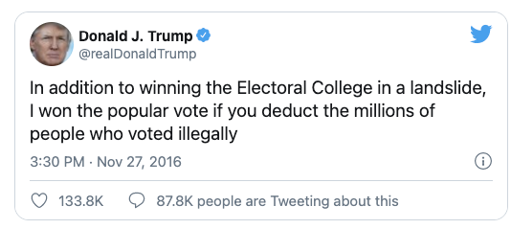

REFERENCES

Abramowitz and Webster **TBA**

Adams, James, Thomas Brunell, Bernard Grofman and Samuel Merrill. 2013. Do Competitive Districts Produce Centrist Politicians. In Norman Schofield, Gonzalo Caballero and Daniel Kselman (eds.) *Advances in Political Economy*. New York: Springer, 331-350.

Alt, James. **1990ish** TBA in Grofman and Davidson (eds)

Bafumi and Herron 2010 **TBA**

Brunell, Thomas L., Bernard Grofman, and Samuel Merrill, III. 2016. Components of Party Polarization in the U.S. House of Representatives. *Journal of Theoretical Politics* 28(4): 598-624.

Carmines and Stimson (**1991 OR SO**)

Carson et al 2019 **TBA**

Cervas, Jonathan R, and Bernard Grofman. 2019. Are Presidential Inversions Inevitable? Comparing Eight Counterfactual Rules for Electing the US President. *Social Sciences Quarterly* 100(4): 1322-1335

Cervas, Jonathan R, and Bernard Grofman (2020a). **TBA** Social Sciences Quarterly

Cervas, Jonathan R, and Bernard Grofman (2020b). **TBA** *Political Geography*.

Davidson, Chandler and Bernard Grofman (Eds.), 1994. *Quiet Revolution in the South: The Impact of the Voting Rights Act, 1965-1990*. Princeton, NJ: Princeton University Press.

Downs 1957 **TBA**

Fraenkel, Jon and Bernard Grofman. 2006. Does the Alternative Vote Foster Moderation in Ethnically Divided Societies? The Case of Fiji. *Comparative Political Studies*, 39(5): 623-651.

Grofman, Bernard and Scott L. Feld. 2004. If You Like the Alternative Vote (a.k.a. the *instant runoff*) then you ought to know about the *Coombs Rule*. *Electoral Studies* 23:641-659.

Hussey, Wesley and John Zaller 2011. Who Do Parties Represent? In Ennis and Wlezien (eds) *Who Gets Represented?* New York: Russell Sage 311-344.

Jacobson 2019 **TBA**

Lee, Frances. 2016. BK **TBA**

Loosemore and Hanby, 1971 **TBA**

Merrill, Samuel. Thomas Brunell, and Bernard Grofman. 2014. Modeling the Electoral Dynamics of Party Polarization in Two-Party Legislatures. *Journal of Theoretical Politics*26: 548-572.

Merrill, Samuel**,** Bernard Grofman and Thomas Brunell. 2020. *Polarization Begets Polarization: The Dynamics of Congressional Polarization* . Book manuscript.

Miller, Nicholas. 2012 **TBA**

Miller, **XX** and Norman Schofield. 2008. TBA *Perspectives in Politics*.

Putnam, Robert *Upswing* **TBA**

Rodden, 2018 BK TBA

Sen and Maskin **TBA**

Thomsen, Danielle 2018. [*Opting Out of Congress: Partisan Polarization and the Decline of Moderate Candidates*](https://www.amazon.com/Opting-Out-Congress-Polarization-Candidates/dp/1316635031/ref=sr_1_2?dchild=1&keywords=danielle+thomsen&qid=1608824993&sr=8-2) ***TBA***

Wang, XXXX TBA

[5] Because we are not looking at intra-state differences in district size, there is no reason to expect impact from the “one person, one vote” revolution.

1. In the 1970s, VRA provisions became applicable also to those of Spanish heritage and to those coming from other historically disadvantaged groups singled out by Congress for special attention.
2. See also Carmines and Stimson (**1991 OR SO**)
3. Confirmation of Amy Comey Barrett was a party line vote, with 52 Republican Senators voting “yea” and 47 Democratic Senators (plus independent Bernie Sanders) voting “nay”. Brett Kavanaugh received 50 “yea” votes, all from Republican senators, and 48 “nay” votes, all from Democrats (Republican Lisa Murkowski (AK) voted “present”, and Steve Daines (MT) did not vote). In contrast, Ruth Bader Ginsberg, a Clinton nominee, received 96 “yea” votes, with only three “nays'' and one non-voter. John Paul Stevens, a Ford appointee, received zero “nay” votes.
4. **When we look at battleground states we find that these are limited in number in both 1900 and 2020.** **JONATHAN PLEASE ELABORATE** .**Indeed, we fear that the pattern of most states almost always under the control of one party is likely to persist even after current realigning trends have had time to play out.** **JONATHAN THIS IS NEW LANGUAGE; PLEASE THINK ABOUT At the congressional level, the vanishing marginals is a well-known phenomenon, and yet control of congress seems always up for grabs.** At the county level we find that **JONATHN FILL IN counties out of JONATHAN FILL IN counties voted for Trump in both 2016 and 2020.**
5. The twenty year period from the 1876 though 1896 bears a striking resemblance to the **first** twenty years of the 21st century in the degree to which presidential elections have been close. During these intervals, **11 of** 12 elections had a popular-vote margin that was smaller than the historical **overall** median **(7.4%)**. **Additionally, only four elections in the 20th century had margins lower than the median for the 21st century elections.**
6. For example, we have arguments such as, “When you look at how close the election was, basically a tie vote in the popular vote if you take out the margin of difference in California.” (Sen. Mike Braun, ID), as well as absurd claims about 6 million votes cast by non-citizens in 2016 and equally absurd claims of massive mail fraud in the 2020 election**.**
7. <https://www.census.gov/prod/cen2010/cph-2-1.pdf>
8. **Even without intentional gerrymandering, the need to draw districts that satisfy the Voting Rights Act, combined with increasing concentration of Democratic electoral strength in cities, has led to a situation in which so-called “natural gerrymandering” leads to some partisan bias – but nowhere near as much as is crated intentionally.**
9. **The ability of legislators to choose their own voters rather than vice versa makes legislators less respectful of the power of the electorate to discipline their behavior. JONATHAN THINK ABOUT WORDING ; I WAS TRYING TO REFERENCE SAM’S POINT**
10. We would also note that **the effects of gerrymandering one decade can linger in subsequent decades, based on incumbency advantage. Also when courts find constitutional violations they limit themselves in the degree to which existing lines are redrawn and usually seek to assure that incumbents are not paired if the geography (and the nature of the violation being remedied) makes that possible.** 
11. The reason for the misperception of the degree of Electoral College malapportionment is that the greatest overweighting occurs in small states who make up a relatively small fraction of the total EC seats, while the larger states are relatively proportionally represented.
12. Merrill, Grofman and Brunell (2020) do specifically test to see if competitive districts need to be treated separately and conclude that, if anything, the parties are further apart in competitive districts than they are in non-competitive districts.
13. Arguably, however, at least during his first term, President Obama did try to work with Republicans but votes on the most critical issues still ended up along party lines.